**T.C.**

**İSTANBUL AREL UNIVERSITY**

**THE TITLE OF THE GRADUATION PROJECT**

**GOES HERE IN ALL CAPITAL LETTERS**

**Graduation Project**

**Your Name Goes Here in Title Format (Only First Letters Capitalized)**

**İSTANBUL, 20..**

**T.C.**

**İSTANBUL AREL UNIVERSITY**

**FACULTY OF ENGINEERING AND ARCHITECTURE**

**DEPARTMENT OF INDUSTRIAL ENGINEERING**

**THE TITLE OF THE GRADUATION PROJECT**

**GOES HERE IN ALL CAPITAL LETTERS**

**Graduation Project**

**Your Name Goes Here in Title Format (Only First Letters Capitalized)**

**Supervisor: Your Supervisor’s Name Goes Here (e.g. Asst. Prof. Dr. ...)**

**İSTANBUL, JULY 20..**

**T.C.**

**İSTANBUL AREL UNIVERSITY**

**FACULTY OF ENGINEERING AND ARCHITECTURE**

**DEPARTMENT OF INDUSTRIAL ENGINEERING**

Name of the project: Your Project Name Goes Here (Title Format)

Name/Last Name of the Student: Your Name Goes Here (Title Format)

dd/mm/yyyy

Supervisor’s Name (Assist. Prof. ...)

We hereby state that we have held the graduation examination of *Your Name* and agree that the student has satisfied all requirements.

**THE EXAMINATION COMMITTEE**

Committee Member Signature

1. ……… (in academic order)………. ……………………………...
2. …………………………..………... ……………………………...
3. …………………………..………... ……………………………...

ABSTRACT

THE TITLE OF THE GRADUATION PROJECT

GOES HERE IN ALL CAPITAL LETTERS

Your Name (Title Format)

Faculty of Engineering and Architecture

Department of Industrial Engineering

Your abstract goes here...

*Abstract should not be more than one page. No reference given here.*

Your abstract goes here...

**Key Words**: keyword1, keyword2, keyword3 …(Write keywords (at least three) of the project here separated by comma, in all small letters)

ÖZET

BİTİRME PROJESİNİN ADI

(BÜYÜK HARFLERLE)

Öğrencinin Adı (Başlık Formatında)

Mühendislik ve Mimarlık Fakültesi

Endüstri Mühendisliği Bölümü

Projenin Türkçe Özeti buraya yazılacak…

Özet 1 sayfayı geçmeyecek. Referans verilmez.

Projenin Türkçe Özeti buraya yazılacak…

**Anahtar Kelimeler**: Proje ile ilgili anahtar kelimeler virgül ile ayrilmiş olarak ve küçük harflerle buraya yazılır.

ACKNOWLEDGEMENTS

First of all….

*to my …*

TABLE OF CONTENTS

ABSTRACT iii

ÖZET iv

ACKNOWLEDGEMENTS v

TABLE OF CONTENTS vii

LIST OF TABLES viii

LIST OF FIGURES ix

LIST OF ABBREVIATIONS x

1. INTRODUCTION 1

1.1. Second-Level Subheading 1

1.2. Another Second-Level Subheading 1

1.2.1. Third-level subheading 1

1.2.1.1. Fourth-level subheading 1

2. LITERATURE REVIEW 3

2.1. Second-Level Subheading 3

2.1.1. Third-level subheading 3

3. METHODOLOGY 4

4. APPLICATION AND RESULTS 5

5. CONCLUSION AND FUTURE WORKS 6

5.1. Conclusion 6

5.2. Future Work Proposals 6

REFERENCES 7

APPENDIX A 8

LIST OF TABLES

Table 1. List of sections contained in this document 5

LIST OF FIGURES

**No table of figures entries found.**

LIST OF ABBREVIATIONS

Word to be defined Write the definition here. Do not put any hard carriage returns in the definition and it will wrap like this automatically. When you are done with the definition, hit one return and the appropriate space for the next definition will be inserted

Next word And the list continues

Another word Remember to use a tab between the abbreviations and the definitions

Note: The paragraphs are single-spaced

.

1. INTRODUCTION

The first-level subheading is centered, boldface, single line spaced, and it advances the text after it by two lines. First-level subheadings must not have more than a single blank line space before or after the heading.

* 1. Second-Level Subheading

This is the second-level subheading of the first section. It is left aligned, boldface and single spaced, and it advances the text after it by one line. Second level subheadings are in Title Case (The first letters of principal words must be capitalized).

* 1. Another Second-Level Subheading

The format of this subheading is the same with the first one. The purpose of this subheading is to show you that if you have a subheading of a certain level, you must have more than one. The rationale is that you cannot have a list of only one item.

* + 1. Third-level subheading

The third-level subheading uses the same formatting with the second-level subheading except that for the third-level subheading, only the first letter of the first word and proper nouns are capitalized (Sentence case).

* + - 1. Fourth-level subheading
      2. ASD

The fourth-level (Sentence case).

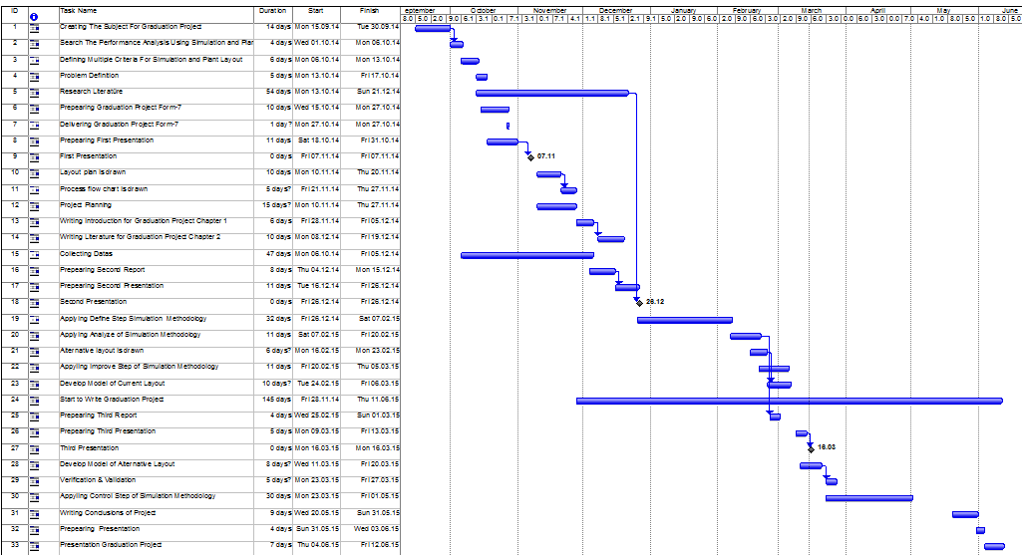

Figure 1. Plan of the Study

1. LITERATURE REVIEW
   1. Second-Level Subheading

This is the second-level subheading of the first section. It is left aligned, boldface and single spaced, and it advances the text after it by one line. Second level subheadings are in Title Case (The first letters of principal words must be capitalized).

* + 1. Third-level subheading

The third-level subheading uses the same formatting with the second-level subheading except that for the third-level subheading, only the first letter of the first word and proper nouns are capitalized (Sentence case).

Table 1. List of sections contained in this document

|  |  |
| --- | --- |
| **Section name** | **This section contains** |
| Title | Title page |
| Acknowledgment | Acknowledgment page |
| Contents | Table of contents page |
| Tables | List of tables page |
| Figures | List of figures page |

1. METHODOLOGY

The methodology of your Graduation Project goes here.

C:\Program Files\Microsoft Office\MEDIA\CAGCAT10\j0157763.wmf

Figure 2. Eiffel Tower

1. APPLICATION AND RESULTS

The application and results of your Graduation Project goes here.

1. CONCLUSION AND FUTURE WORKS
   1. Conclusion

The conclusion of your Graduation Project goes here.

* 1. Future Work Proposals

REFERENCES

[1] Bass, E.M. (1969) A new product growth for model consumer durables. *Management Science* 15(5) 215-227.

[2] Bass, P.I., Bass. E.M. (2004) IT waves: Two completed generational diffusion models. Working paper, School of Management, The University of Texas at Dallas, Richardson, TX.

[3] DeKimpe, M., Parker, P.M., Sarvary, M. (2000) Multi-market and global diffusion. V. Mahajan, E. Muller, Y. Wind, eds. *New- Product Diffusion Models*. Kluwer, Boston, MA.

[4] Bass, F. M. (1963) A dynamic model of market share and sales behavior. Proc. *Winter Conference American Marketing Association*, Chicago, IL.

**Web References**

[5] Caron, M. L., Performance Appraisal Methods and Some Cautionary Notes, http://www.performanceimprovement.ca/briefin%201.htm, retrieved at 21 Nov. 2007.

[6] http://en.wikipedia.org/wiki/Analytic_Hierarchy_Process, retrieved at 28 May. 2008

# APPENDIX A

Your appendix goes here.

**RESUME**

Your full name goes here. (centered)

Your email address goes here. (centered)

Your address goes here. (left aligned)

Your telephone number goes here. (left aligned)

**Career Objective:** Indicate your expected college area of concentration or plans after high school.

**Education:** Begin with ―David W. Butler High School‖ and the years you have attended school here (for example, ……..-2008). In reverse order list (latest first) any other high school (s) you have attended (and dates).

You may insert certificates you had.

**Honor Degrees and Courses:** List honor degrees you had (latest first). List any upper-level courses you have taken such as courses you got AA

**Honors/Awards/Clubs/Community Services:** List all you can think of, but be truthful. Don’t make up any! Include community, organization awards as well as school-related ones. List service, other volunteer experience, scouts, etc.

**If the previous two categories (Honor Courses & Honors and Awards) do not apply to you, you may substitute those categories with “Special Interests,” “Hobbies,” or “Technical Skills.” (Remember, the goal is to show your very best.)

**Work Experience:** Again, list in reverse order with dates (practical training/ internships/ volunteer summer trainings).

**References:** Give names, addresses, and telephone numbers for two people who could provide a character reference for you or information about your work or volunteer experiences. (GP supervisor is a good one). Be sure to verify that these people are willing to serve as your references prior to including them on your resume.

***RESUME SHOULD BE NO MORE THAN ONE PAGE***